BUILDING A DASHBOARD ON DATABRICKS

Senzekile Ayanda Nsimbi
Student no : 2805001628
01 JUNE 2026

- SCREENSHOTS OF THE CODE USED TO CREATE VISUALIZATIONS
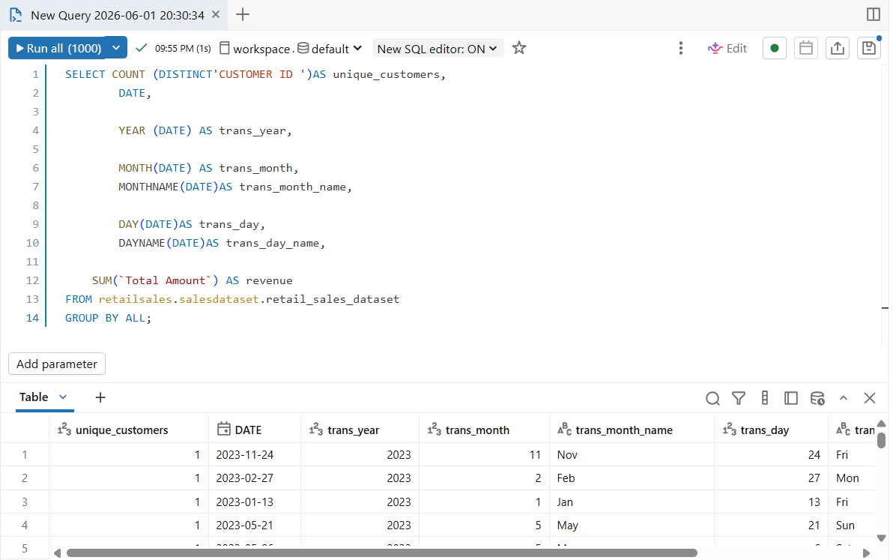

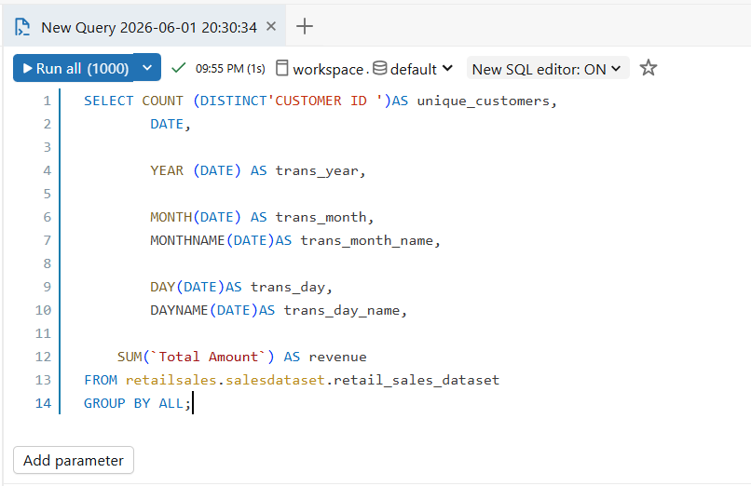

- SCREENSHOTS OF INDIVISUAL GRAPHS

Bar graph
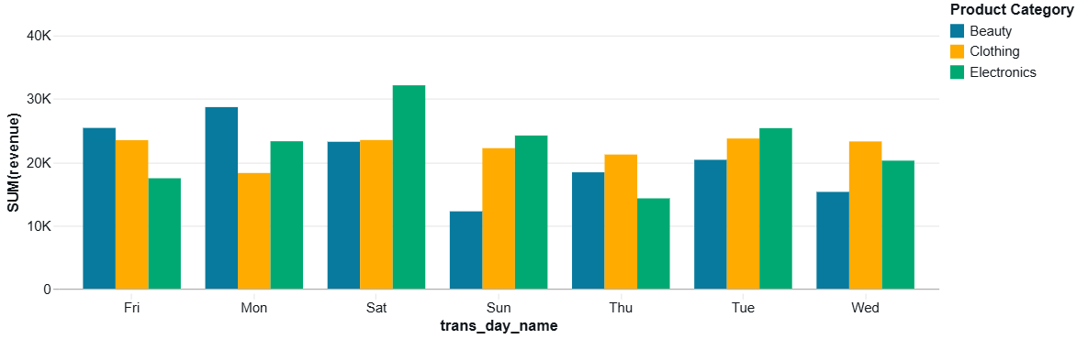

Pie Chart graph


Line Graph
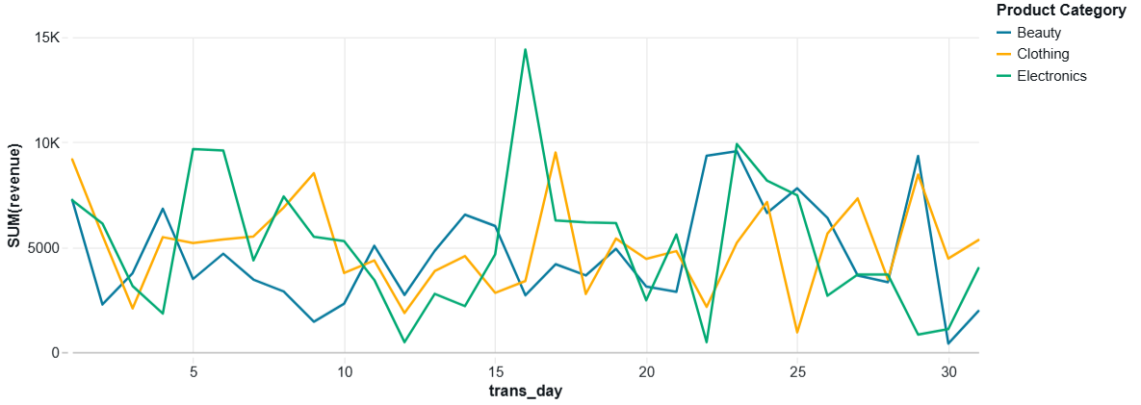

Line graph
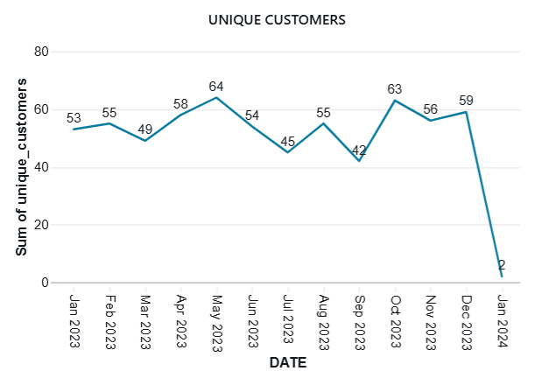

- DASHBOARD SCREENSHOT

